Linda Cosgrove
EI-24794
6318 East 181st Avenue
Hebron, IN 46341

July 13, 2016

Mr. David Navecky
Via: STB Website Environmental Comments

Re: Docket # FD 35952 – Great Lakes Basin Tranportation

Dear Mr. Navecky,

In Eagle Creek Township, Lake County, Indiana, we have a rather unique situation when dealing with precipitation - both snowfall and rain and how both relate to the condition of State Road 2 (SR 2) east of I-65 and its topography within the community, as well as the adjoining roads to the south where almost the entirety of the proposed Great Lakes Basin Transportation railroad (GLBT) proposes to build.

Because the area south and adjacent to SR 2 is designated as flood plain, hazardous flood plain and floodway, the static water levels are shallow – from 4 inches to 10 inches and with an abundance of hydric soils. The reason: There was, up to approximately 100 years ago, a 600,000 acre marsh known as the Grand Kankakee Marsh. The marsh was subsequently drained through a series of man-made ditches and drain-tiled for agriculture. In fact, this holds true for all of the area east of the intersection of SR 2 & Clay Street and all the way into Illinois. The proposal would cause some significant and irreversible problems: 1.) Inability to stop flooding because with the static water level, there is little room for excess water to go. Adding rails would additionally block any natural or man-made route where the surface water might eventually settle, thus causing horrific drainage problems adding to the problems that already exist. 2.) It would also appear that any significant weight (from trains & tracks) could collapse in such wet and sandy soils . 3.) Such significant weight upon these flood plains would cause collapse of the drain tiles. The farmers have spent hundreds of thousands of dollars providing underground drains in their fields to adequately grow their crops.

When there is a significant rain, any low spots on SR 2 flood because not only are there high static water levels adjacent to this road but the elevation from just one mile north drops by some 40 feet often bringing the run-off down to SR 2. These conditions leave not much room for the rain or snow-melt to settle into the ground – thus creating amounts of surface water which results in flood conditions.

Many times in my last 22 years of residence, SR 2 has been closed to any thru-traffic at all and many times a state-of-emergency has been declared. This is due to either rainfall or snow with blowing wind. County Sheriffs and/or County workers block the intersection of SR 2 & Clay to stop traffic from travelling east and often they are parked near SR 2 & Colorado (1 mile west of Clay)preventing any traffic from coming east even to Clay Street. It has, at times, been so flooded that the water height east of SR 2 & Clay has been measured at 2’ above the road and fish swam over the road!

In winter time, the snow has also caused the closure of this road and several states-of-emergency were declared. Due to the topography of the area and the open fields, there is little to stop the snow drift nor can the plows keep up. County and/or state workers must, too often, just give up and simply close the road. Mother Nature is simply too strong in this area. Being in such close proximity and due south of Lake Michigan, the snow fall can be horrendous. I can’t count the number of times people have spent the night in their cars and semi-trucks/trailers on SR 2 simply because the road couldn’t be cleared and the wind caused such huge drifts that even the snow plows got stuck. Law enforcement used snow mobiles and even helicopters to bring gas (to keep the heat going in vehicles) and food to the stranded motorists or to airlift residents out of their homes. There is absolutely no getting through SR 2 until Mother Nature decides to cooperate.

Just this past winter while the road was once again closed, my daughter who is a 911 Dispatcher & was on duty, called me at 11 PM to ask that I try to call one of the area farmers to use his tractor to pull the emergency vehicle (who was stuck in the snow on SR 2) to the home of the person in need. The tractor pulled the emergency vehicle to the home and then to the intersection of I-65 & SR 2 where an ambulance was waiting to transport. The farmer was located east of the proposed tracks while the patient was located west of the proposed tracks. I can’t emphasize enough the dire situation that could have occurred had there been the addition of a train that may have additionally blocked the road.

We also have a unique situation whereas I believe the wind velocity in Eagle Creek Township exceeds that of the surrounding areas. I’m not a weather professional so can’t answer expertly but this is the best explanation I could find from the Iowa Energy Center. “…All valleys are not necessarily poor wind sites. When oriented parallel to the wind flow, valleys may channel and improve the wind resource. A constriction to the valley may further enhance wind flow by funneling the air through a smaller area.” I would propose that since the Valparaiso Morraine at elevation 750’ just two (2) miles north meets SR 2 and the general area at elevation 650’ with north/south roads running every mile, this could, indeed, be the reason we have such high winds in our small area. Further, “The surface over which the wind blows affects its speed. Rough surfaces, such as areas with trees and buildings, will produce more friction and turbulence than smooth surfaces such as lakes or open cropland. The greater friction means the wind speed near the ground is reduced.” We don’t have much “friction” that would slow wind speeds. We often see “dust devils” and mini-tornados. Even on a calm day, there is wind. This wind is responsible for the heavy, heavy snow drifts that cover SR 2 making it impassable. Too often we hear of semi’s that have blown over on I-65 which is just up the road by 1-1/4 miles of SR 2 & Clay.

On two separate occasions, multiple huge electrical towers just north of SR 2 near Clay have crumbled like toy erector sets under these heavy winds. Those towers are directly in the footprint of the proposed tracks. On another occasion, all of the electrical/telephone poles for approximately two miles were blown over by the high wind and dangling over SR2 (in the footprint of the proposed tracks). The result, this time, was one full week without power. The snow plows couldn’t get in because the poles were angled down near the road and the power company could not access their power poles because no-one could get through the road to plow. These are not isolated incidents but a couple of the worst. We’ve had many states-of-emergency declared due to weather-related conditions. Now, add to these already existing safety Issues with possibly 110 trains per day causing further complications. It simply will not work.

In this small community, the wind speeds, inability to maintain SR 2 as a through-way in storms (as well as surrounding roads) and shallow water levels too often cause unpredictable and dangerous conditions. Please do not burden and further endanger the citizenry. The safety of our community should be paramount in your consideration of this railroad. Please stop this project from going any further!

Respectfully,

Linda Cosgrove

Attachments Pg. 2

Attachment – FD 35952

A few examples from testimony in comment.:

NW Indiana continues winter storm cleanup – February 25, 2016
Dozens of vehicles were stranded along State Road 2 between US-231 and I-65 in Northwest Indiana and on the same stretch of road along Route 17 in Illinois near Grant Park, Illinois.

Many drivers spent the night at the Indiana State Police District 13 headquarters (1/2 mile west of SR 2 & Colorado) in Lowell as they waited for crews to clear the roads and dig their cars out.
http://wgntv.com/2016/02/25/state-of-emergency-declared-in-several-counties-in-nw-indiana/

Thousands Without Power, Scores Of Vehicles Stuck In Snow After Blizzard
One person in Lowell called 911, but ambulance crews couldn’t reach them, so first responders waited for a snowmobile team to go in and make an evacuation. (This is a separate incident from where I mention my daughter).
“It’s treacherous. There’s probably 50 cars, trucks, semis, tow trucks, plow trucks just buried. There’s no passing getting through there,” said Bob Taylor, who rescued his wife after she got stuck on Route 2 for about nine hours on Wednesday. “My wife was stranded there from 2:30 yesterday. They kept saying the plow was coming, and at 11:30 I went and picked her up on a snowmobile and brought her home. She was like 4 miles down the road from our house.”
The only way to quickly navigate the normally busy east-west route Thursday morning was on snowmobile, so CBS 2 photojournalist Dino Pillizzi hitched a ride on one, and saw firsthand how the storm even halted snowplows in their tracks.
http://chicago.cbslocal.com/2016/02/25/thousands-without-power-scores-of-vehicles-stuck-in-snow-after-blizzard/

RAW: Transmission tower down in Hebron, IN after severe storm June 13, 2013
In northwest Indiana, State Road 2 was closed Thursday morning between US 231 and I-65 – that’s in southeast Lake and southwest Porter Counties.
Storms brought down power line towers in that area overnight.
WGN’s Skycam 9 flew over the area Thursday morning.
The Indiana Department of Transportation says it could be three days before the road reopens.
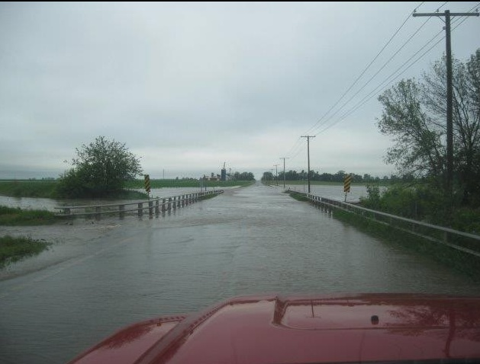
http://wgntv.com/2013/06/13/raw-transmission-tower-down-in-hebron-in-after-severe-storm/

Page 3

