Linda Cosgrove
6318 East 181st Avenue
Hebron, IN 46341
(219)996-3230

July 14, 2016

Mr. David Navecky
Surface Transportation Board
Via STB Website Correspondence

Re: Docket 35952 – Great Lakes Basin Transportation

Dear Mr. Navecky:

I am writing today to oppose the Great Lakes Basin Transportation proposal for the following reason:

Lake, Porter & La Porte Counties in Indiana are very precarious locations to site a new railroad.

The railroad is being proposed within an area where there is absolutely no other source of water than our complicated series of aquifers in the Kankakee Basin/Kankakee Watershed. Some of the static water levels are as shallow as six (4) inches. The Kankakee Basin has not only a complicated geology but an equally complicated system of confined and unconfined aquifers. When, not if, a derailment or other mishap occurs, hazardous substances would be immediately in our groundwater as it is so shallow.

One would think that because of our close proximity to Lake Michigan, water could be piped into us. That is an impossibility. The Great Lakes Charter (2005) & the Great Lakes Compact (2008) is an agreement between Illinois, Indiana, Michigan, Minnesota, New York, Ohio, Pennsylvania and Wisconsin, as well as the Canadian Provinces of Ontario and Quebec who, collectively, control the use of the water in the Great Lakes. If one looks at the maps, Lake Michigan would logically be the closest water source for us in the case of contamination of our water supplies. However, due to our topographical location outside of the Lake Michigan Basin, it simply can’t be done, let alone approved. Any water diverted from the Lake must be returned to the Lake. Any water diverted from the Lakes must have approval of the Great Lakes Board of Directors.

We are outside the Lake Michigan Watershed in the Kankakee Basin, south of the Valparaiso Morraine in Lake, Porter & La Porte Counties. Patton should have named his project the Kankakee Basin Transportation as there is not one inch located within the Lake Michigan Basin in any of the three states. (See below)

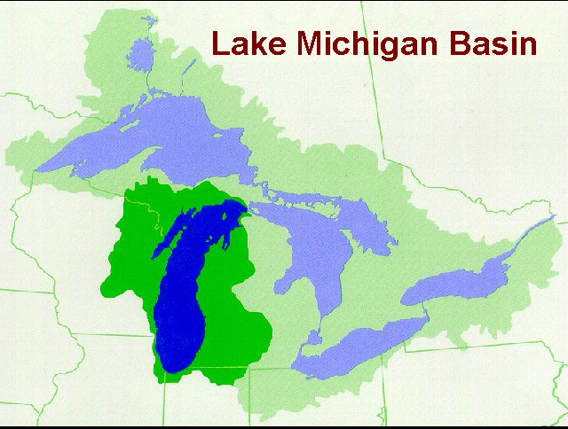

The Town of Lowell tried to get Lake Michigan Water in the late 80’s because of high fluoride levels. In 1992, they were denied. Lowell had no choice but to dig deep wells at a cost of hundreds of thousands of dollars.

To get water replacement in the case of contamination, we could use bottled water, I suppose. However, bottled water wouldn’t water the crops or quench the livestock. Bottled water would not fill a bathtub or a sink to do dishes. We would have to dig a deep well at the cost of at least $200,000. Who can afford that kind of money?

If Patton’s tracks carry someone else’s trains and there is a catastrophe, who would be responsible for the costs of replacing our wells? Patton’s LLC company? I think not. Could the damage be mitigated? Doubtful – remember our complicated series of aquifers. Our local health department ordinance says that if there is no water in our homes, we can’t inhabit them. Where would we go?

With all of the accidents and derailments that have recently occurred while carrying hazardous material, the question is not if it happens. The question is what do we do when it happens?

There couldn’t be a worse location with regard to the environment and our only water source.

Please stop this project from going any further. There is absolutely no need for the project and we, the citizenry, should be allowed to live in peace without this threat hanging over our heads.

Respectfully,
Linda Cosgrove

