“The nation that destroys it’s soil, destroys itself” Franklin Delano Roosevelt
EI-25036

7/14/16

Dave Navecky
Surface Transportation Board
Docket No FD 35952
395 E Street SW
Washington DC 20423-0001

Dear Mr. Navecky and Members of the Surface Transportation Board,

I am writing in opposition to the Great Lakes Basin Railroad Line proposed route through Rock County Wisconsin.

The current proposed route through Rock County Wisconsin will take at a minimum 575 acres of farmland located on the Rock Prairie. The heart of this productive fertile land is a proposed side rail for railroad car parking and layover area the width of a football field and approximately one mile long. The location lies over the one of the primary aquafer source of water for the City of Janesville (population 63000 people) and the main source for well water for the people living in these Rock County townships. My concern is this “Multiple Train Parking Lot” will be located over the primary drinking water source for Rock County Residents ( population160000), including the city of Janesville (est. population 63575).

According to the United States Geological Survey/Wi: “In Wisconsin, 70% of residents and 97% of communities rely on groundwater as their drinking water source. Wisconsin has abundant quantities of high-quality groundwater, but once groundwater is contaminated, it's expensive and often not technically possible to clean. Because of these factors, we need to be careful to protect our groundwater from contamination. Our activities on the land can contaminate groundwater - most contaminants originate on the land surface and filter down to the groundwater.”

Additionally, The USGS: Geology and Ground Water Resources of Rock Wisconsin (Water Supply Paper 1619-X) states: “Rock County is within the drainage basin of the Rock River, which flows southward through the center of the county. The western and southwestern parts of, the county are drained by the Sugar River und Coon Creek, both of which flow into the Pecatonica River in Illinois and thence into the Rock River. The southeastern part of the county is drained by Turtle Creek, which also flows into Illinois before joining the Rock River. Nearly all the lakes and ponds are in the northern one-third of the county, the area of most recent glaciation. The aquifers in Rock County are of sedimentary origin and include deeply buried sandstones, shales, and dolomites of the Upper Cambrian series. This series overlies crystalline rocks of Precambrian age and supplies water to all the cities and villages in the county.”

In addition, within close proximity to the proposed route and “Train Parking Lot” through Johnstown Township, Rock County WI are several natural spring areas and natural water and drainage ways.
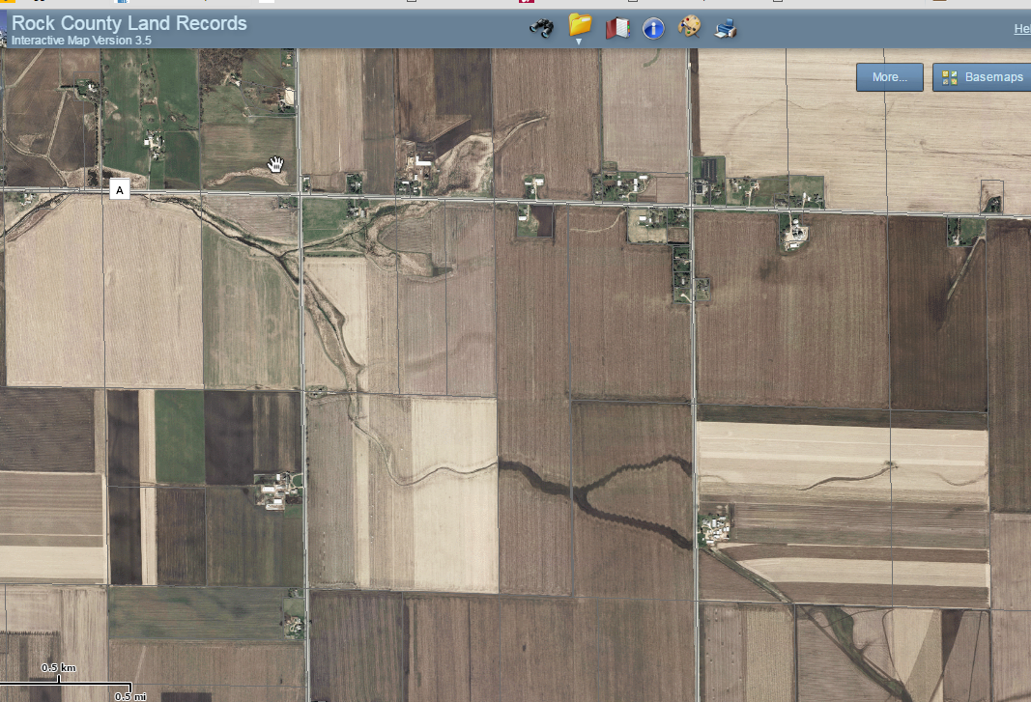

For over 150 years my family and the many family owned farms within the path of this proposed railway has provided careful stewardship of this precious resource through our farming practices.

I urge the Surface Transportation Board to fully investigate the environmental impact to soil, water, and air quality of the proposed location of the Great Lakes Basin Railroad.

Sincerely

Linda M. Viney
Janesville, WI

