EI-25034
ATTN: Docket #FD35952

Mr. Dave Navecky
Surface Transportation Board
Office of Environmental Analysis
395 E Street SW
Washington, DC

Mr. Navecky,

We are a farm family in Lowell, IN and are deeply concerned about the effect this proposed railroad will have on our farm and our community. We have many of the same concerns that have already been expressed which include safety, effect on our first responders, hazardous spills and our community’s ability to respond to them, the noise and disruption this train will forever cause and potential air quality issues.

As a farm family, one of our biggest concerns is the impact this will have on the existing land use patterns in regards to our operation as well as our ability to handle the numerous drainage issues this train will cause.

Figure 1 and Figure 2 below represent two major areas of our farming operation (everything within the white outline we farm). As you can see the rail line cuts greater than 1,500 acres directly in half!! This will cause major increases in the time it takes to spray, till, plant, fertilize and harvest the crop. In addition, this will make an already dangerous job even more dangerous and will cause some of the land to be landlocked which means we won’t be able to get to it to farm it anymore. Finally, most of our water runs north to south so you can see how this rail line will cause serious issues with the drainage.
Figure 1
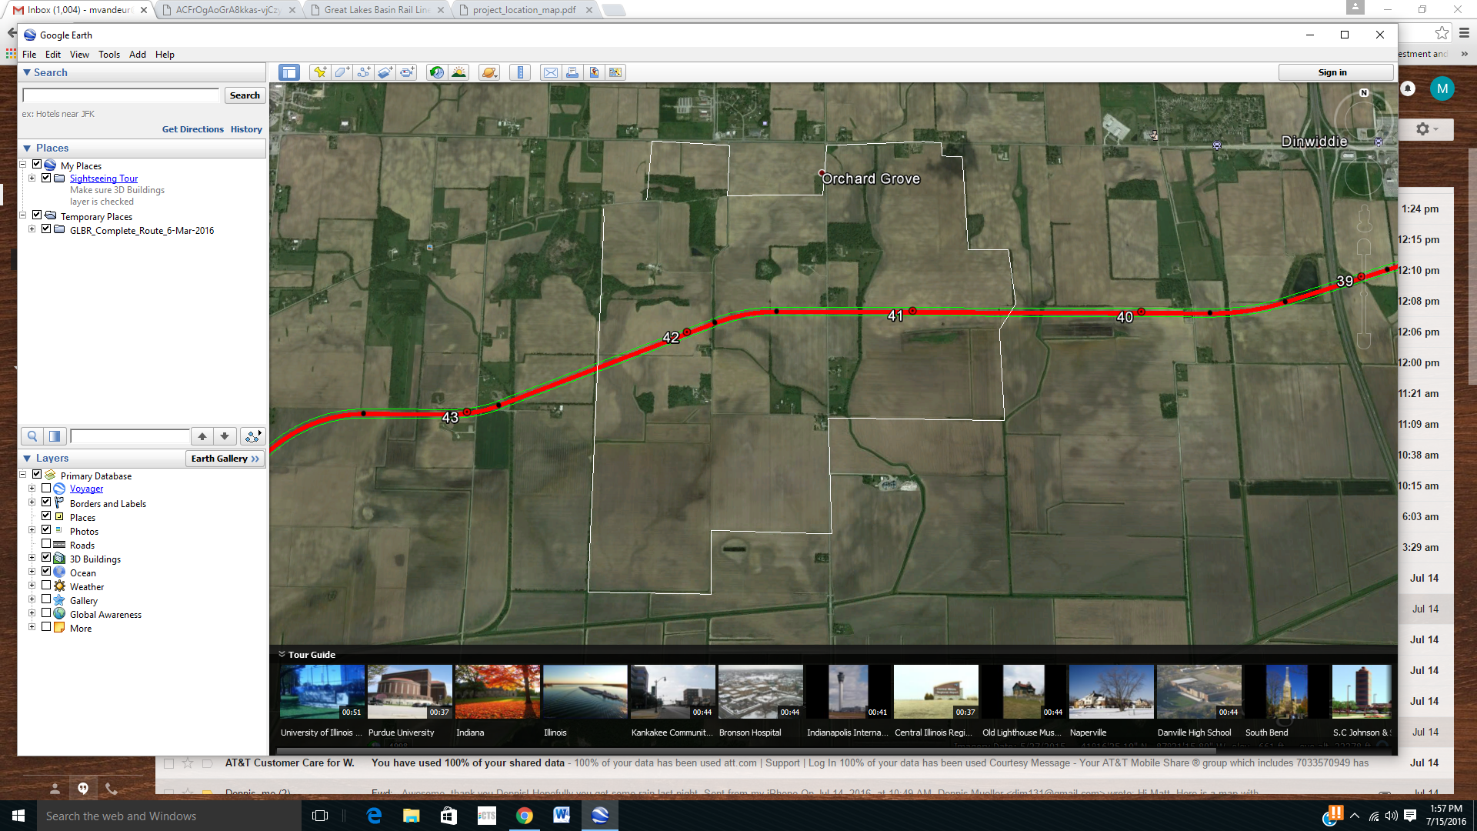

Figure 2
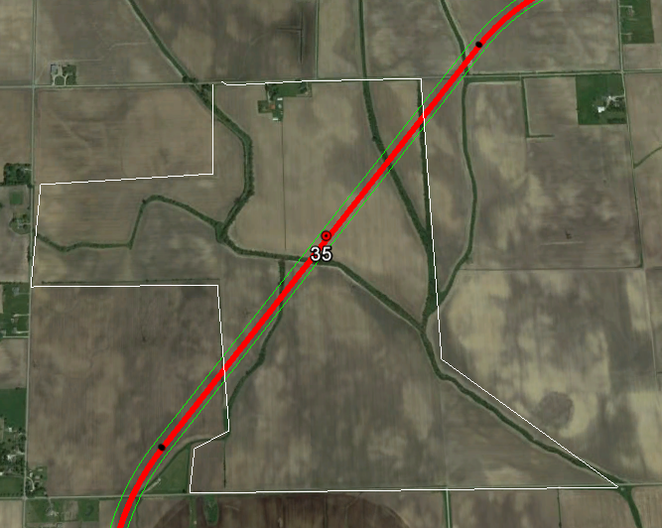

Figure 3 below shows the two farmsteads where we operate our farm . This train directly splits our two locations and would cause a road closure on Grant St which we traverse thousands of times a year. Again, causing major delays and added costs to our operation. Who is going to reimburse all of the affected farmers for the added costs and reduced revenue this train is going to cause?

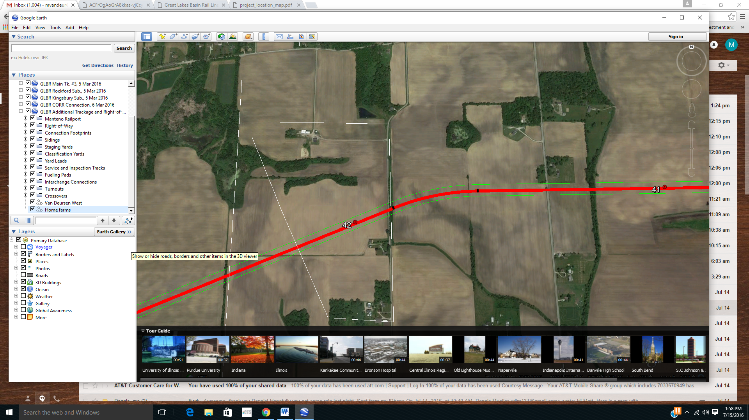

Finally, I would like to stress that we are only one farm family along this 278 mile railroad. Thousands of us will be severely impacted in a negative way. We strongly oppose the GLBT railroad and encourage you to do the same.

Thank you,

The Van Deursen Family

