April 20, 2016
Nancy & Karl Hulin
4197 E 1950th Rd
Leland, IL 60531

RE: Great Lakes Basin Railroad
Dear Mr. Navecky,
We are writing regarding the Great Lake Basin Railroad proposal that is set to run, based on its current route, about ¼ of a mile from our house. We live in rural northern LaSalle County, IL on about 3 acres of land. We moved here almost 7 years ago.
While we understand the need to move product quickly and as cheaply as possible to keep costs down, we have to express the concern we have for the route this is looking to follow, most importantly, through the surrounding area where we are located.
We were aware of the high water table in our area and the increased likelihood of flooding when we purchased our home. Most of this occurs during the springtime and lucky for us, it is mainly kept to our back acre with some minor water in our basement. However, our neighbors to the south (3 homes) experience this flooding to a much larger degree. What concerns us is that if this proposed 200 foot easement, which we’ll assume will have some raised elevation to it, is put between our homes and the creek that the water dissipates to, will increase the flooding to a point that my neighbors’ homes may no longer be habitable. It will also increase the flooding in the surrounding farm land, causing local farmers to lose additional crops. I’m sure the water will also flood more of our acreage as well as cause more frequent and most likely more substantial flooding in our basement. We are inclosing pictures of what the flooding is now. You’ll notice that our neighbor’s driveway already becomes impassable in the current state. The water in our back acre rises to 2 to 3 feet deep. In essence, this building of any kind of berm or raised grading for the railroad will impede the natural flow of water causing extensive yearly flooding above and beyond what currently occurs.
Another issue is the effect on our local emergency personnel and their ability to get to rural locations in a timely manner. This railroad will close roads as well as the train traffic blocking other main roads where these first responders are trying to reach those in need. How much damage could a brush fire end up causing because the fire department has to drive 3 miles out of their way and wait for a train at one the numerous crossings? There would be three road crossings within 1 mile of our house, 1950th Rd, 42nd Rd and Rt. 23, which a train a mile long would close all three at the same time.
While we may just be few in numbers in our immediate area, the potential disruption of the natural water flow and increased flooding would be very detrimental to not only us but many others. We have only raised two of the most important issues to us. There are many other negative impacts that this proposed railroad would create to the surrounding farms and communities that many others have communicated.
The section on the left hand side in the black box is where the railroad would cross 1950th Road. The creek that the water flows to is about ½ mile beyond where the railroad will be. This is also from a mild flood so this isn’t as high as the water has been.
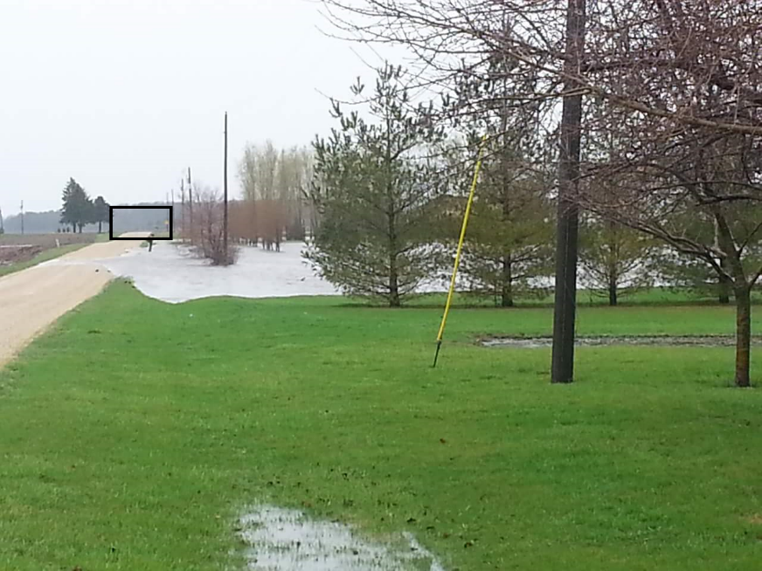
The section in the black box on the picture below is our neighbor’s driveway which is fully under water.
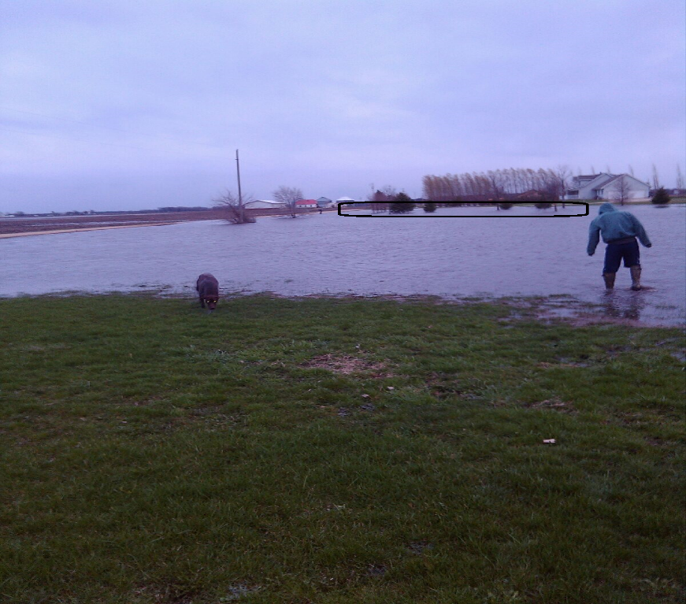Warm regards,
Nancy & Karl Hulin

