EAGLE ROCK FARM
EI-24715
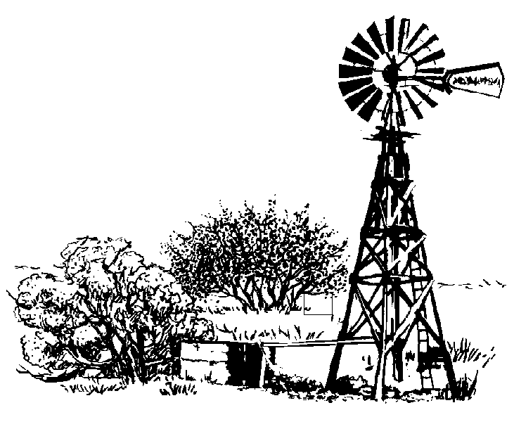
JERRY & SUSIE HAYDEN
MATT & CHARI HAYDEN
BOBBY HAYDEN
4203 E. 173rd Ave.
Hebron, IN 46341
Phone: (219) 996-6923
Cell phone: Jerry 219-746-5713 Susie 219-746-5719
Matt 219-746-5714 Chari 219-746-5717
Bobby 219-746-5718 Fax: 219-996-6923
E-mail: shayden@airbaud.net

ATTENTION: Docket # FD 35952

Mr. Navecky
Surface Transportation Board Docket
395 E Street, SW
Washington, DC 20423

Mr. Navecky,

I am a young farmer in southern Lake County, Indiana. We are a family farm. My mom & dad have worked hard over the years to build up the operation that we have today. I have one brother that farms with us and a brother and sister that work off the farm. My Dad is 74 years old, and still working every day on the farm. He works hard so that he can leave this legacy to his family. Mr. Patton says he wants to build this railroad so he can leave a legacy to his children. I believe that our farm and many others in this proposed area have a right to keep our legacy.

I live on the farm that this proposed railroad would split diagonally in half. My house is about 700 feet from the proposed railroad. Our 225,000 bu grain operation is on the same building site. We have a scale on that property that would be affected by the constant trains going by.

This farm is known to have Indian artifacts on it. I have attached a map of Lake County Indiana from 1890. I live in Section 25 which has the Shore Line running right through it. Everything south of this Shore Line was swamp ground with several islands located between the shore line and the Kankakee river. Indians would camp along this Shore Line. There are many Indian artifacts that are found on these farms. If you look at the larger map of Lake County, you will see that this Shore Line runs through many of the sections that this proposed railroad also runs through. (Taken from a book by T.H. Ball Copyright 1890)

I would ask that you use your option to refuse this permit and keep our farm land intact.

Sincerely,
Bobby Hayden
18210 Clay Street
Hebron, IN 46341

