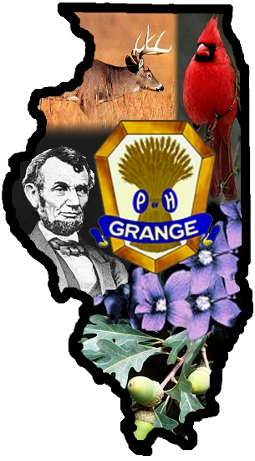 July 14, 2016
EI-24926
Illinois State Grange
Master/President
Lynette Schaeffer
10041 Rieder Road
Lebanon, IL 62254-2509
618-537-4237
618-979-5546
schaeffr@att.net
Overseer Karie Blasingame Belvidere
Lecturer Patty Bearth Belleville
Treasurer Kevin Joseph O’Fallon
Secretary Elaine Hecathorn East Peoria

Executive Committee
S. Wayne Lyford Rockford
Gary Hecathorn East Peoria
Frank D Wurth Mascoutah
Mr Dave Navecky
Surface Transportation Board
Docket No. FD 35952
395 E Street SW
Washington, DC 20423-0001

Mr. Navecky,
I am writing to you on behalf of the members of the ILLINOIS STATE GRANGE and the members of Grange communities in Boone, DeKalb, LaSalle and Winnebago Counties who will be impacted by the proposed Great Lakes Basin Railroad to be built between Milton, WI and LaPorte, IN.
Many Grangers have attended the public scoping meetings held in IL to find out more about the proposal. The “details” presented were sketchy at best and many members left the meetings with more questions than answers. Members of an Indiana Grange discussed the issue at a Great Lakes Grange Leaders meeting in Indiana in April, they were concerned by much of what they had heard and read up to that point. Wisconsin Grangers have also expressed concern to me via email since that time.
The National Grange has a long history of standing against unfair railroading practices. Maps of this proposed rail line show Illinois communities where at least 9 Granges and hundreds of Grangers would be affected. Some of them directly as they own property or lease farm property in the proposed area.
The points that have been brought to my attention in this matter and I would like to bring to you include;
- The landowners are concerned with the dissection of their large farm fields into smaller, less manageable fields. This dissection will affect water drainage and conservation practices implemented in the large field. The environmental impact to the area needs to be studied and protection of the ecological resources of the area need to be a significant portion of the decision concerning this proposal.
- The potential negative impact upon the people living near the rail line caused by the loss of rural township road access. The possible road closures will affect response times from law enforcement, fire and medical personnel. We believe this is a real safety concern for those living in the affected areas.
- The National Grange has a long standing policy of supporting the Government’s use of eminent domain to obtain land needed for necessary public works projects. However, the policy opposes the Government’s use of eminent domain to take property from private landowners and turn it over to another private venture such as Great Lakes Basin Railroad.
- Great Lakes Basin Railroad is a private venture seemingly something Mr Frank Patton wants to ‘offer’ to the communities. We are skeptical of offers of this nature from someone who does not have a railroad background, who has been involved with a failed project in WI and IL (proposed private toll road), and who has not named investors for the project.
- Many rail lines are closing down at this time, I have one near my home that has now been closed for about one year and at this time there is no plan to re-open it. That line had been used daily until it was closed. So building a new line at this time does not seem like a reasonable endeavor.
- At this time we know of no other railroad interested in participating in Mr. Patton’s venture. So we question the necessity of this project with on other involvement from existing railroad.

With these points in mind, we would encourage the Surface Transportation Board to study all the valid information before making any decisions on the proposed route, or any alternate routes for the Great Lakes Basin Railroad.

Fraternally,
Lynette L Schaeffer, Master
Illinois State Grange

