September 19, 2017
Case Control Unit,
Washington, DC 20423
Attn. Josh Wayland

From: Fred Wert, Rail-Trail Planning Services
Re: Docket No. AB 1244X and AB 1243X
Re: Environmental Assessment Comments
I am an expert on the development of rail-trails having spent the last 30 years working on them throughout the northwest. I have written a book on rail-trails, taught a course, been a speaker at national conferences, been interviewed on the radio, worked for the Rails-to-Trails Conservancy, developed master plans, and negotiated on the transfer of railroad property to public agencies. I managed a non-profit that worked closely with Seattle, BNSF, and local industry to acquire and railbank a BNSF line for both trail and rail use under a so-called modified PCN. I am very familiar with the Railbanking process as well as the Section 106 process.
It is my opinion that the railroad line proposed for abandonment would make an excellent trail under the National Trails System Act. This railroad right of way has long been identified by many planning documents in Cowlitz County as an excellent candidate in order to develop a trail from Longview/Kelso, which is on the I-5 corridor between Seattle and Portland, to the Mt. St. Helens National Monument.
On page 10 of the EA there is this statement the author states “The conversion of a rail line into a trail allows for historic sites and structures to be preserved and for the rail right-of-way to remain intact.” I believe this statement may be based largely on the assumption that the applicant for abandonment has not altered the physical condition of the rail line prior to seeking abandonment authority. However, this assumption, or statement, is not the case in this situation. The applicant has removed historic structures and a significant amount of the rail bed prior to filing for abandonment. I attach some pictures showing before and after conditions relating to a box culvert removed prior to seeking abandonment authority. Moreover, on page 1 of the Environmental Report filed by Patriot and CLC dated August 3, 2017 it states “Some of the track between milepost 17.98 and the end of the line, has already been removed.”

While I certainly support OEA’s recommendation, at p. 11 of its report, that “that the Board impose a condition stating that CLC shall retain its interest in and make no changes to any historic properties located within the APE until the Section 106 process is complete,” this is not adequate where there is evidence, as here, of an unlawful defacto abandonment.
This agency issued a policy statement (“Consummation of Rail Line Abandonments…, Ex Parte No. 678, served April 23, 2008) which in part states as follows (slip op. p. 2):
“A railroad may not ‘abandon’ a rail line (i.e., be relieved of its common carrier
obligation to provide rail service over that line and dispose of the property for non-rail use)
without express permission from the Board. Chi. & N. W. Transp. Co. v. Kalo Brick & Tile Co.,
450 U.S. 311, 321-22 (1981). Under 49 U.S.C. 10903, the Board may affirmatively approve the
abandonment of a line by determining that the public convenience and necessity require or
permit the proposed abandonment. Alternatively, the agency may authorize abandonment by
granting an exemption (individually or by class of rail lines) under 49 U.S.C. 10502. See
49 CFR 1152.50 and 1152.60. Under either procedure, the Board must meet its responsibilities
under other Federal statutes, including NEPA, NHPA, and the National Trails System Act (Trails
Act) at 16 U.S.C. 1247(d). To meet those responsibilities, the Board may need to impose
conditions that limit or postpone the carrier’s ability to exercise its abandonment authorization in
whole or in part.”

The policy statement also explained, slip op. at p. 4) that
“In some cases railroads have taken actions affecting rail property without first seeking
abandonment authority. When this occurs on inactive lines, we generally do not discover these
actions until after the fact when the carrier seeks abandonment authority. Such actions are
unlawful. Not only is the rail line unlawfully severed from the national transportation system
when this occurs, but the Board’s ability to carry out its obligations under NEPA and NHPA may
then be adversely affected. The Board will continue to carry out its obligations under those
statutes and will take whatever steps necessary to enforce compliance with them. Railroads that
take such actions may find not only that obtaining abandonment authority is delayed, but that the
Board will require historic preservation training for the railroad’s staff members who are
involved with abandonment projects and require the railroad to document the in-house measures
that it will implement to prevent such actions from occurring in the future. Other possible
actions the Board may take include restricting the railroad’s future ability to employ expedited
procedures to obtain abandonment authority, imposing a financial penalty, and seeking a legal
remedy against the railroad in a court of law.”

Here CLC has already removed historic structures on this railroad and altered the rail bed without seeking abandonment authority, in connection with what is clearly a common carrier rail line long suitable for continued public use.. Given the unknown adverse impact of the actions that have already been taken by CLC and Patriot on this line I am requesting an Environmental Stay be imposed allowing time for this agency, and at least SHPO and other concerned agencies or organizations, to make a thorough inspection of the damage that has already been made to the right-of-way that is being requested to be abandoned. It also appears that the actions of CLC may have triggered a need for a Section 106 review and I request to be a party to that Section 106 process. If the removal was intentional, other provisions of the National Historic Preservation Act, such as “section 110(k),” may be applicable as well, barring issuance of an abandonment license.

By my signature below, I certify service by USPS, first class, on this date on September 19, 2017 the attorney for the railroad parties.

Respectfully submitted,
Fred Wert
P.O. Box 847,Winthrop, WA 98862
509-996-3642
fredwert@methownet.com

cc. Louis E. Gitomer, LLC

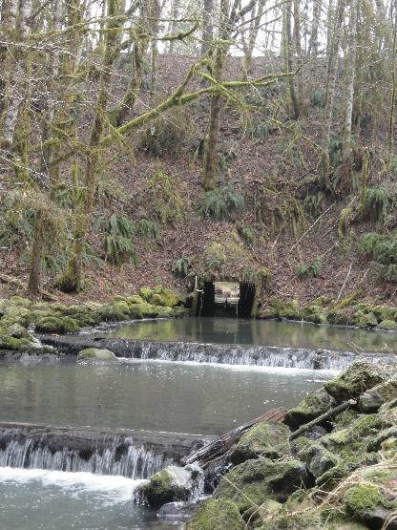
Original historic wood box culvert with railroad grade being the flat area at top of photograph.
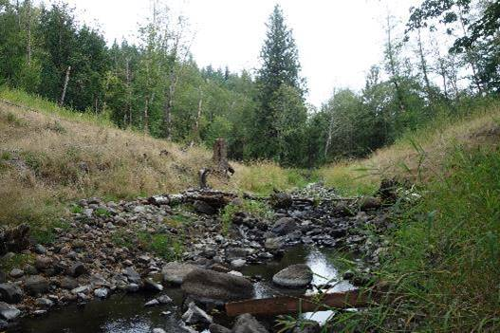
Same location as above photograph taken after culvert was removed.

