I oppose this project. This isn't just about environmental concerns – it's about our families and community bonds. I live just one block away from the proposed bridge site, where three generations of my family have created our home. My son and his wife chose to return to Eagle Pass from Kyle, Texas, specifically so their young daughter – my five-year-old granddaughter – could grow up surrounded by both the Maldonado and Barrera families. With another grandchild due in August, we're faced with the prospect of having this precious family dynamically disrupted by a massive infrastructure project that threatens the very neighborhood we've worked so hard to build together.
We will be BOXED IN, Right side of my house a massive Railroad and on my backyard an International Commercial Bridge, then a couple of blocks on my left is the exit of all tractor trailer that will be crossing from Mexico into the US, Since we don’t have just one entry and exit on Hwy 277, those 18 wheelers will be crossing town in front of my home. We the people from Cenizo Heights and Seco Mines will be breathing deiseal fumes all day and night.
International Commercial Bridge Hopedale RD Hwy 277 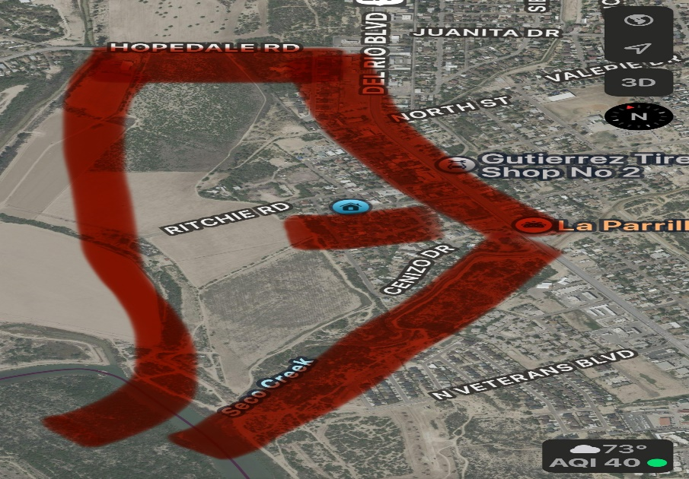
Mexico Seco Creek the Railroad

