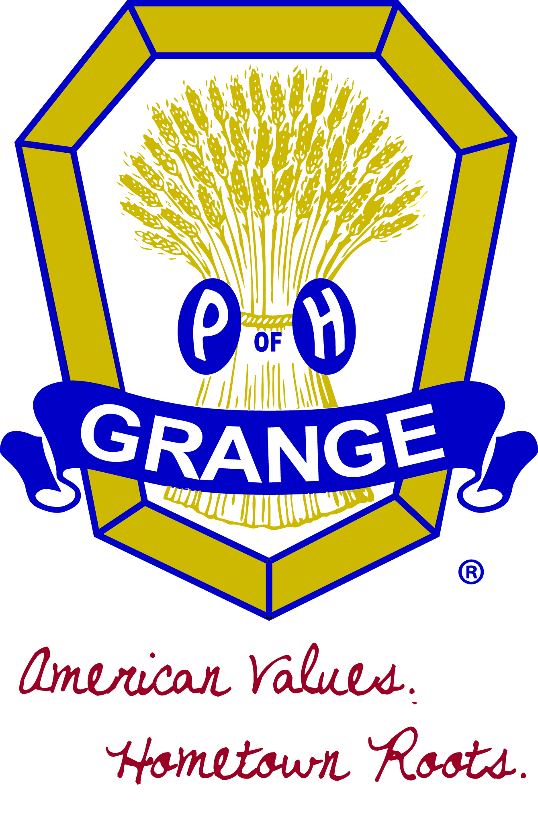
John Plank, Master
EI-25068
Indiana State Grange
National Grange Asst. Steward
johnpplank@gmail.com
(765)414-4152
7843 S. US HWY 231
Brookston, Indiana 47923

June 13, 2016

Mr. Dave Navecky
Surface Transportation Board
Docket No. FD 3595289
395 E Street SW
Washington, DC 20423-0001

Mr. Navecky,

I am writing to you on behalf of the members of the Indiana State Grange and the members of Grange communities in Lake, Porter and La Porte Counties who will be negatively impacted by the proposed Great Lakes Basin Railroad to be built between Milton, Wisconsin and La Porte, Indiana.

I have been in contact with several members who have attended public scoping meetings held in Indiana to find out more about the proposal. We feel like this is being thrust upon the affected land owners with very little notice and left with more questions than answers about the railroad. At our Great Lake Leaders Conference in April at Crown Point IN, our members discussed this issues with members from Wisconsin and Illinois Granges. Both Wisconsin and Illinois members are also concerned by what they read and hear. Many of our subordinate Granges and members have already sent in letters of concerns to you.

The National Grange has a long history of standing against unfair railroading practices. Maps of Mr. Patton's proposed rail line show Indiana communities where at least 3 Granges and many Grange members would be affected. Some of them directly as they own property or lease farm property in the proposed area. The land owners are concerned with the dissection of their large farm fields into smaller, less manageable fields. This dissection will effect water drainage and conservation practices implemented in the large field. The environmental impact of the area needs to be studied and protection of the ecological resources of the area needs to be a significant portion of the decision concerning this proposal.

The potential negative impact upon the people living near the rail line caused by the loss of rural township road access. The possible road closures will affect response times from law enforcement, fire and medical personnel. We believe this is a real safety concern for those living in the affected areas. The proposed route seems to have been drawn at random, and in the information that is available Mr. Patton does not offer a reason for why the route was planned where it has been shown.

Reading material provided by the Great Lakes basin Rail Line, there are several statements that are very concerning to my members and the community leaders in the affected Towns and Counties. First, there is the fact that Mr. Frank Patton has no railroad operational background to draw from. Mr. Patton is a wealthy man who thinks that this railroad will be a good idea. Information provided indicates that there had not been a new rail line built in the last one hundred years.

Also, in that same time frame numerous rail lines have been discontinued in Northern Indiana and repurposed as recreational trails, such as the C&O Trail, Erie Lackawanna Trail, Oak Savannah Trail, Veteran's Memorial Bikeway and Monon Trail all in Lake County Indiana. There is the Calumet Trail, Iron Horse Heritage Trail and Prairie Duneland Trail in Porter County.

Finally, the National Grange has a long standing policy of supporting the government’s use of Eminent Domain to obtain land needed for necessary public works projects. However, the National Grange policy also opposes the government’s use of its Eminent Domain authority to take property from a private citizen and turn it over to another private venture. This proposal is exactly that, it is a private venture that is banking on the government to take private property, turn it over to another private entity and that entity has no guarantee for the land owner that the project will succeed. And if it fails, the environmental impacts on the local communities will fall to the local governments to attempt to mitigate the damages. Mr. Patton has not named any investors in his corporation, he has not shown any support for the project for the other rail lines in corridor, and he has played a shell game of vague statements and answers to questions, which do not allow the affected land owners to have a concrete sense of how this proposal will actually work.

With the overwhelming lack of support from the States, Counties, Townships and private land owner’s affected I urge the Surface Transportation Board to not recommend the proposed route, to not recommend an alternate route but to recommend “No Action” on this proposal.

Thank you for your time and consideration.

Sincerely,

John Plank, Master
Indiana State Grange

